A
REPORT
ON
ONLINE BOOKSTORE

As a part M.sc(IT & CA)
Year 2010-2011

Project Developed By:
Jalpesh G Chhaya & Mahesh R Gohil
M.Sc(IT & CA) SEM- 3

Submitted To
Saurashtra University(Rajkot)

College
H.N.Shukla College Of IT & MGT
Rajkot

PROFILE

Student Information

Name: Gohil Mahesh R / Chhaya Jalpesh G
Mo.No: 9974248698 / 9714047979

College Information

Name: H.N.Shukla College Of IT & MGT
Address:Vaisaligar-2,Near Amrapali
Cinema,Opp.Krushanagar Vidhalaya
Rajkot.

Project Details

Project Title:Online Bookstore
Platform:Asp.Net & Microsoft Access

Guide Information

Nilesh Advani

PREFACE

This real life website is developed by for submission of the course as a student of H.N.Shukla College Of IT & MGT,Rajkot. This websites deals with real life problem regarding to books activities of anyOnline Bookstore information.

This websites is based on Asp.Net principles and is designed to automate all the activities required to be carried out as regard to books. By use of this websites get all information about Online Bookstore.

With the help of this website they can save their time in books manually. In this website design we used Microsoft Access as back end tool,which gives highest data security,which is necessary for the safe data secure to any website. It’s also includes a dissertation to be submitted by each of the M.Sc(It & CA) student as a part of the curriculum.

ACKNOWLEDGMENT

The presentation of this report gives us the feeling of fulfillment. At the final frontier towards achieving a master degree the activity of going through industrial orientation has bridged the gap between the academics and practical real life work for us. It has prepared us to apply ourselves better to become good it professional. Naturally, it required a lot of people’s support to complete this training. We take this opportunity to acknowledgement their support to us.

We are also grateful to Nilesh Sir who guided and helped me in all the technical issues related to the websites. He took interest in our work and gave us right directions. Without their directions it was difficult to complete the websites successfully.

DETAILS OF HARDWARE & SOFTWARE USED

HARDWARE SPECIFICATION:

Pentium ||| processor with 333 Mhz
Benq color Monitor
250 GB HDD.
1 GB RAM
Keyboard.
Mouse

SOFTWARE SPECIFICATION :

Microsoft windows 98/NT/2000/Xp
Asp.Net
Microsoft Access

DEVLOPEMENT TOOLS

ASP.NET

- Introduction
After the release of Internet Information Services 4.0 in 1997, Microsoft began researching possibilities for a new web application model that would solve common complaints about ASP, especially with regard to separation of presentation and content and being able to write "clean" code. Mark Anders, a manager on the IIS team, and Scott Guthrie, who had joined Microsoft in 1997 after graduating from Duke University, were tasked with determining what that model would look like. The initial design was developed over the course of two months by Anders and Guthrie, and Guthrie coded the initial prototypes during the Christmas holidays in 1997.

The initial prototype was called "XSP"; Guthrie explained in a 2007 interview that, "People would always ask what the X stood for. At the time it really didn't stand for anything. XML started with that; XSLT started with that. Everything cool seemed to start with an X, so that's what we originally named it. The initial prototype of XSP was done using Java,^{[3]} but it was soon decided to build the new platform on top of the Common Language Runtime (CLR), as it offered an object-oriented programming environment, garbage collection and other features that were seen as desirable features that Microsoft's Component Object Model platform didn't support. Guthrie described this decision as a "Huge risk", as the success of their new web development platform would be tied to the success of the CLR, which, like XSP, was still in the early stages of development, so much so that the XSP team was the first team at Microsoft to target the CLR.
With the move to the Common Language Runtime, XSP was re-implemented in C# (known internally as "Project Cool" but kept secret from the public), and renamed to ASP+, as by this point the new platform was seen as being the successor to Active Server Pages, and the intention was to provide an easy migration path for ASP developers.
Mark Anders first demonstrated ASP+ at the ASP Connections conference in Phoenix, Arizona on May 2, 2000. Demonstrations to the wide public and initial beta release of ASP+ (and the rest of the .NET Framework) came at the 2000 Professional Developers Conference on July 11, 2000 in Orlando, Florida. During Bill Gates' keynote presentation, Fujitsu demonstrated ASP+ being used in conjunction with COBOL, and support for a variety of other languages was announced, including Microsoft's new Visual Basic .NET and C# languages, as well as Python and Perl support by way of interoperability tools created by Active State.
Once the ".NET" branding was decided on in the second half of 2000, it was decided to rename ASP+ to ASP.NET. Mark Anders explained on an appearance on The MSDN Show that year that, "The .NET initiative is really about a number of factors, it's about delivering software as a service, it's about XML and web services and really enhancing the Internet in terms of what it can do ... we really wanted to bring its name more in line with the rest of the platform pieces that make up the .NET framework.
After four years of development, and a series of beta releases in 2000 and 2001, ASP.NET 1.0 was released on January 5, 2002 as part of version 1.0 of the .NET Framework. Even prior to the release, dozens of books had been written about ASP.NET, and Microsoft promoted it heavily as part of their platform for web services. Guthrie became the product unit manager for ASP.NET, and development continued apace, with version 1.1 being released on April 24, 2003 as a part of Windows Server 2003. This release focused on improving Asp.

Category Table:
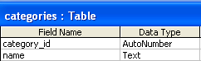

Card_Types Table:
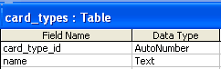

Editorial Category Table:
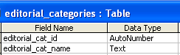

Editorials Table:
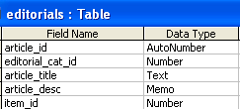

Item Table:
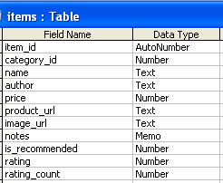

Member Table:
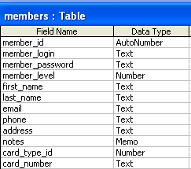

Order Table:
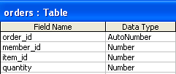

Login Form

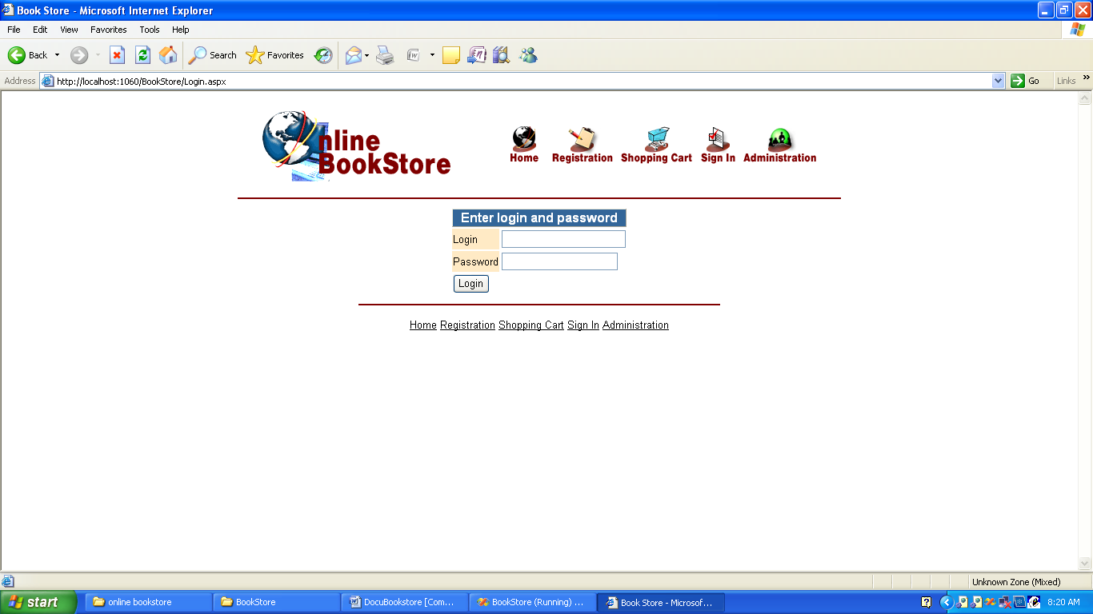

User Information

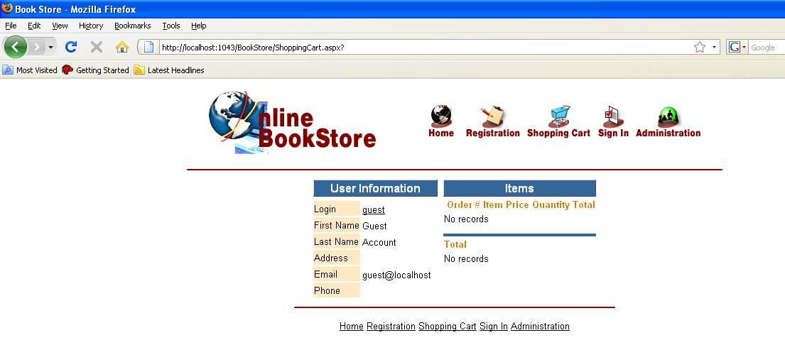

Home Page

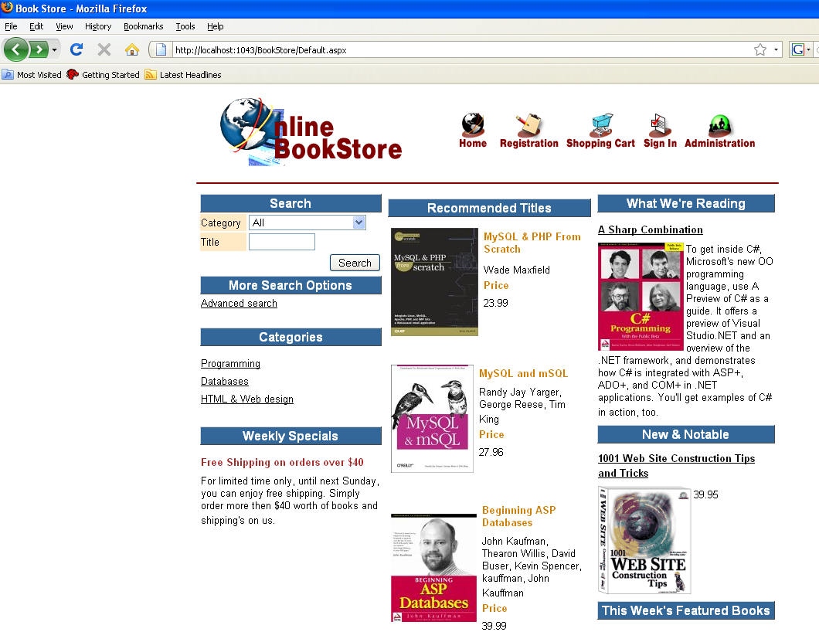

Search Result

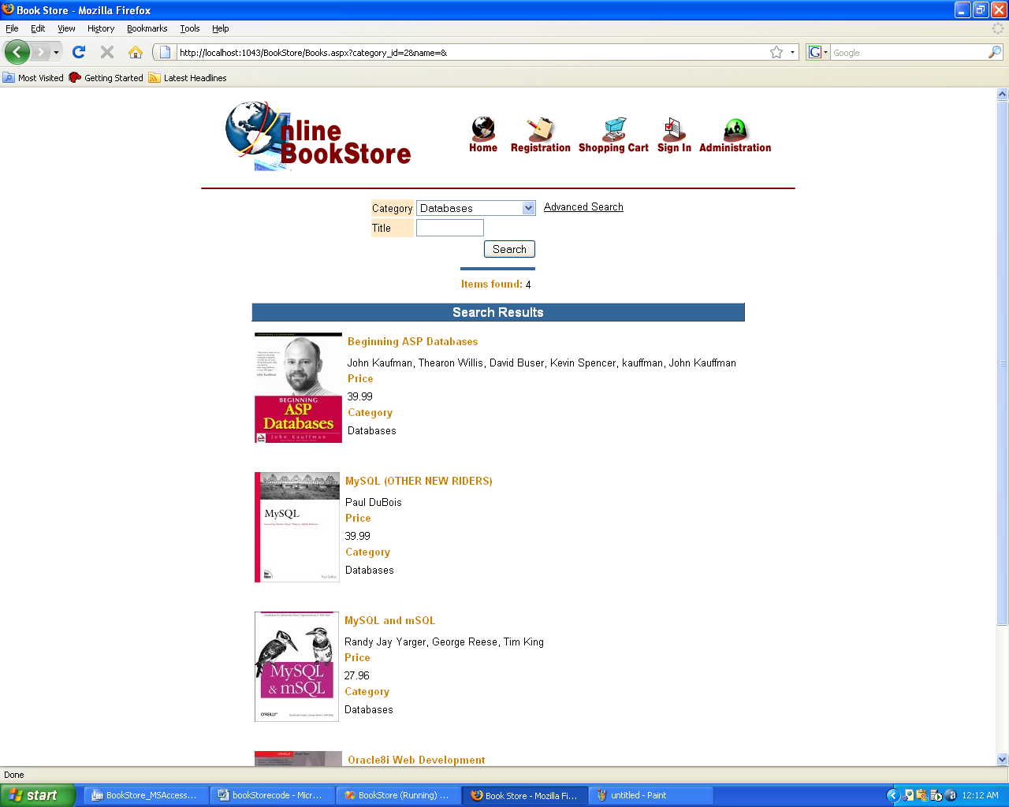

Advanced Search

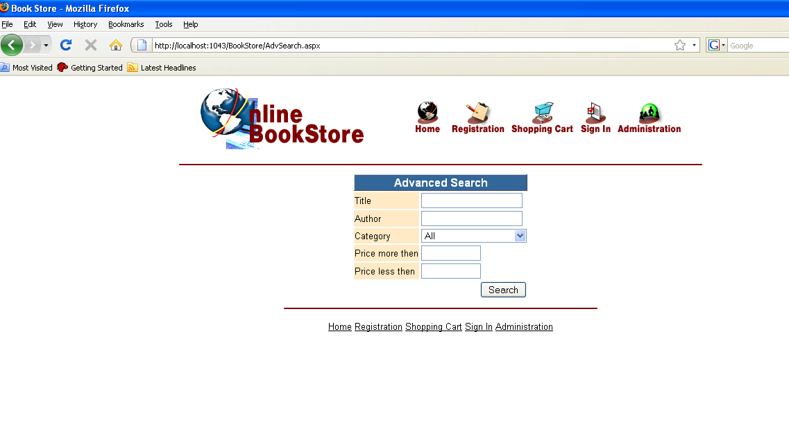

Display Category wise

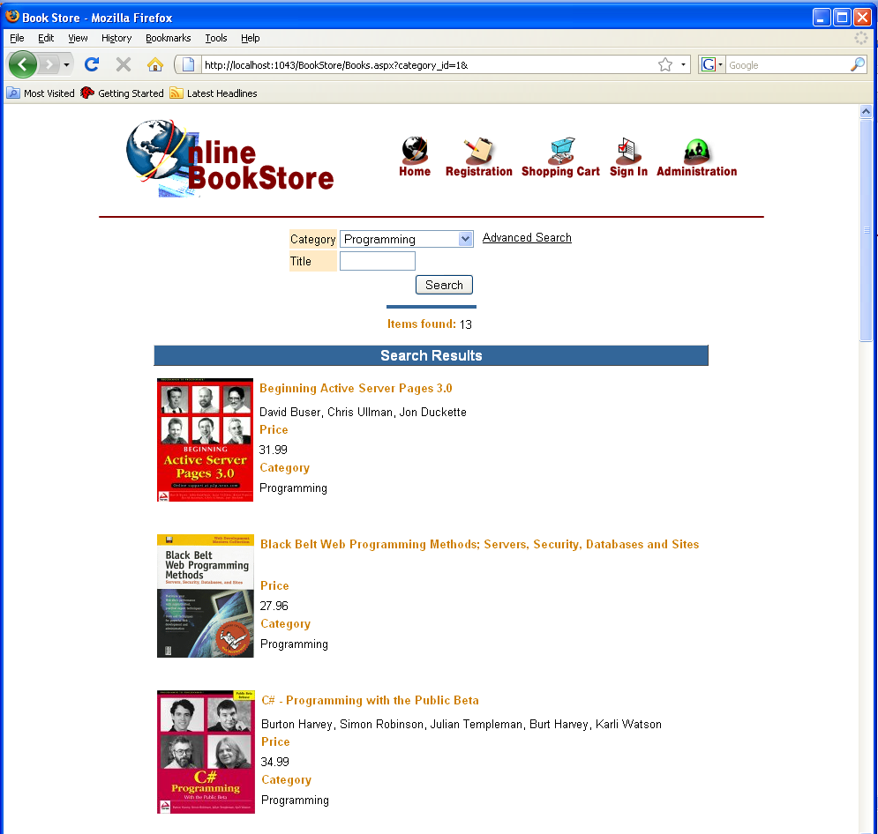

Registration Form

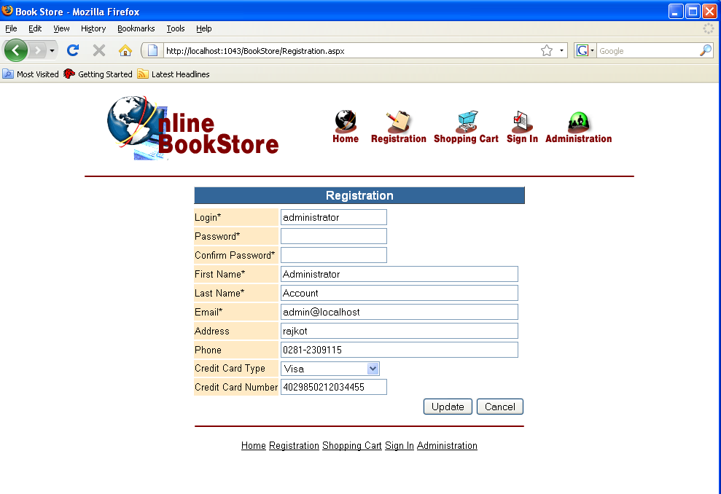

Shopping Cart

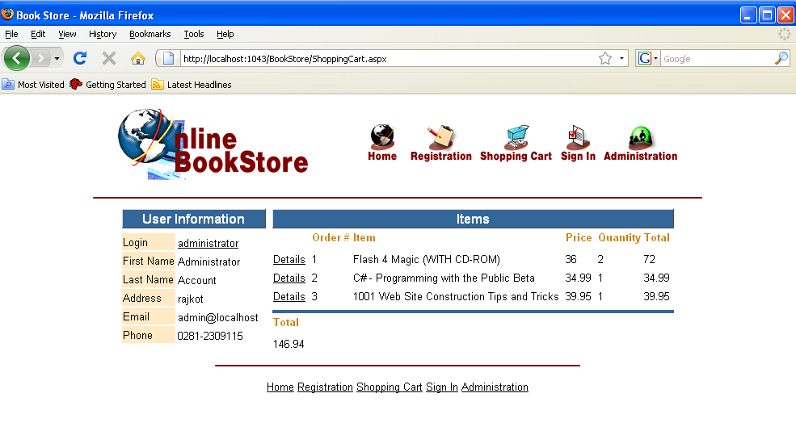

Administrator Menu

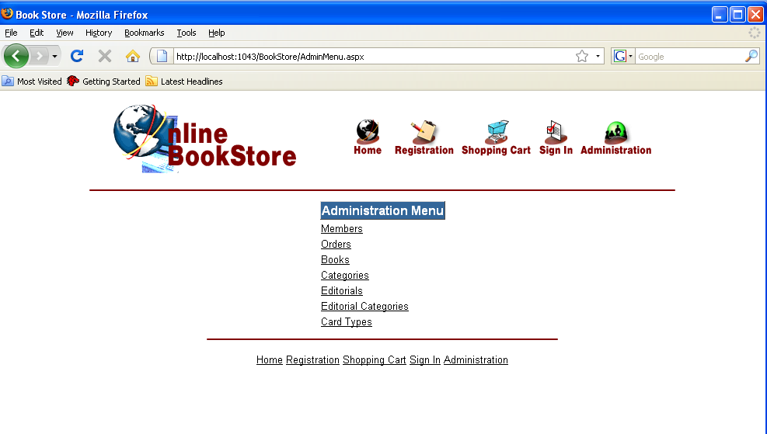

Add Member

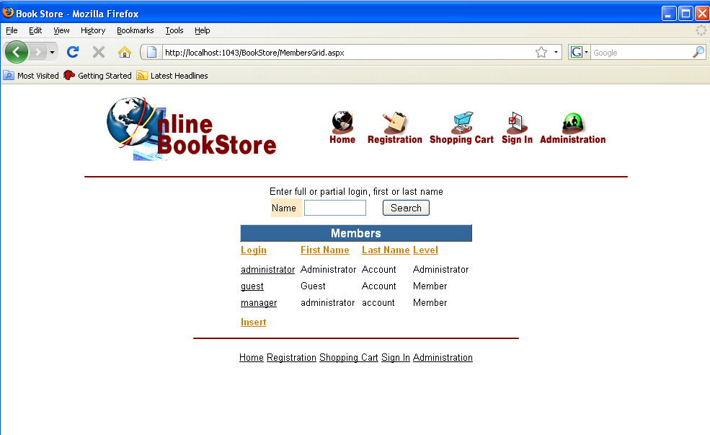

Order Details

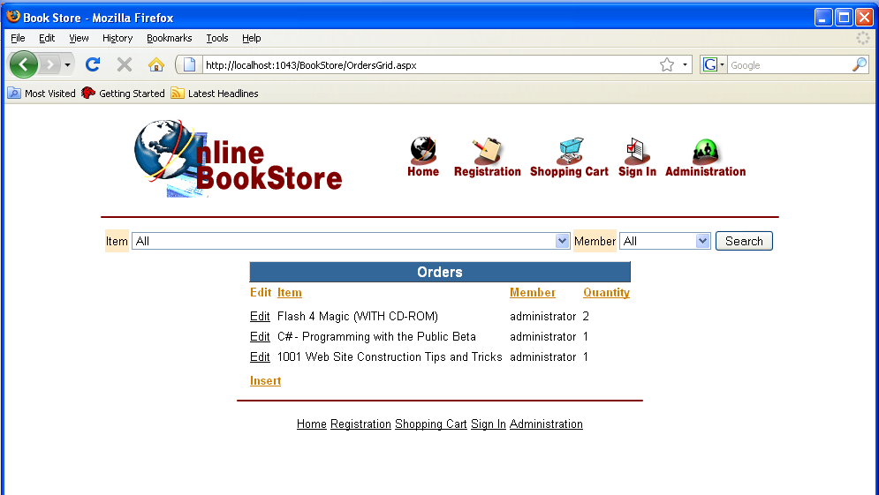

Book Information

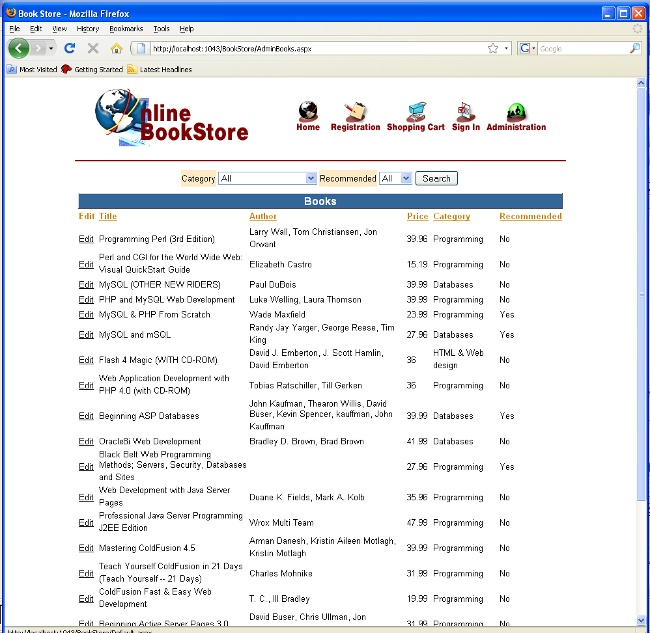

Categories

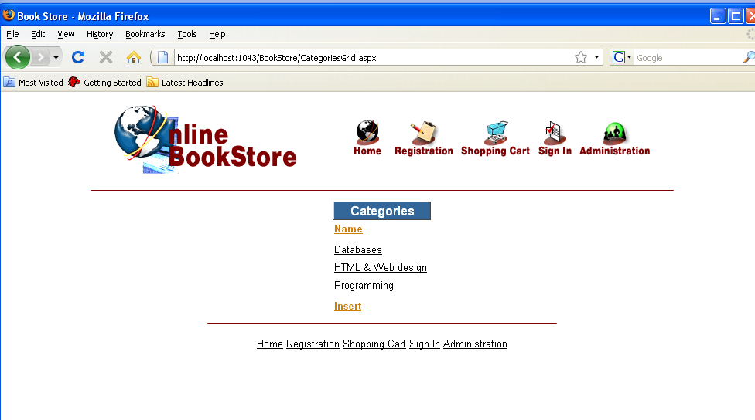

Editorials

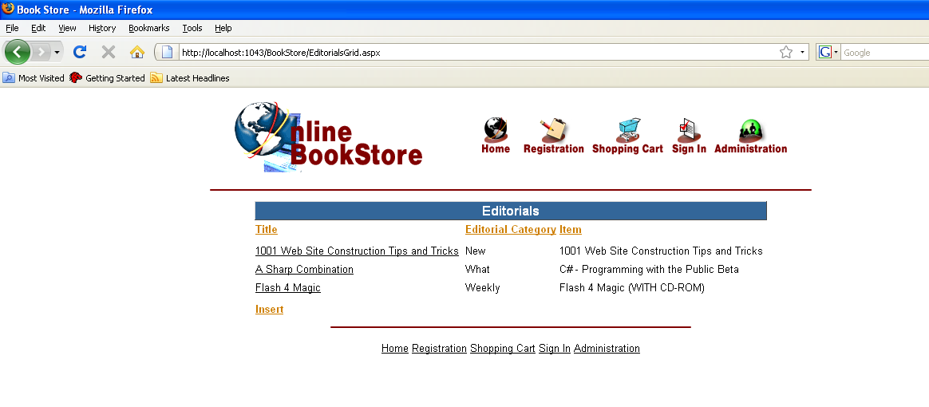

Editorial Category

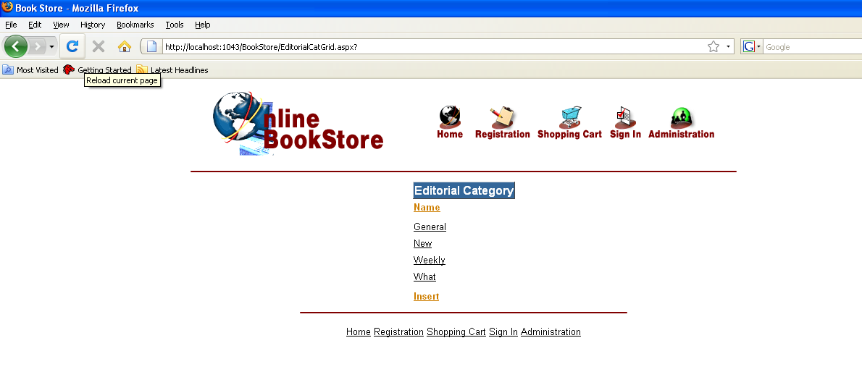
Card Type

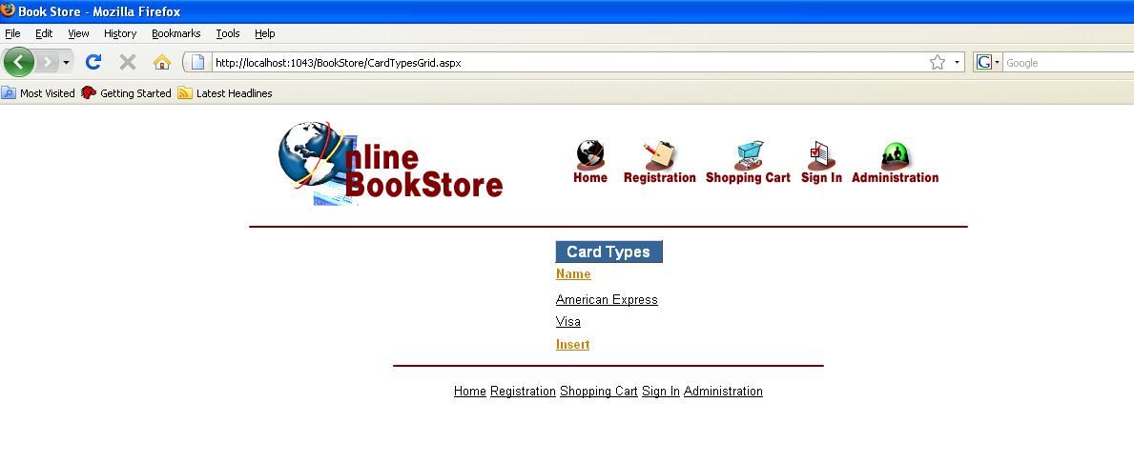

BIBLIOGRAPHY

- ASP.NET 2.0 Black Book
- Professional ASP.NET 3.0

